**Leaders | Put out more bunting  
社论|装点更多彩旗**

（英文部分选自经济学人20220604期社论版块）

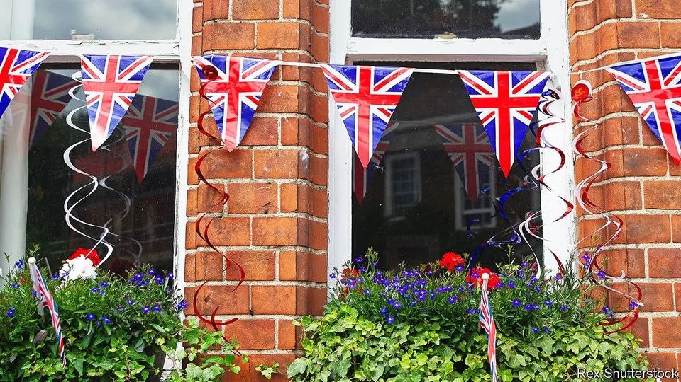

The significance of the Platine Jubilee

论白金禧年的重要意义

The fêtes are absurd, but the queen represents continuity and consensus

庆祝活动不免荒诞，但女王象征着传承与共识



 Her first solo engagement took place in 1942, when she inspected the Grenadier Guards at Windsor Castle. More than 21,000 ribbon-cuttings and plaque-unveilings have followed, along with 200-plus official portraits and over 300,000 congratulatory telegrams sent to centenarian subjects. From June 2nd to June 5th Britain celebrates another milestone for Queen Elizabeth II: the Platinum Jubilee, to mark her 70 years on the throne.

1942年，当时还是伊丽莎白公主的女王在温莎堡检阅了皇家掷弹兵近卫团，这是她首次单独参加公众活动。后来，她参加的剪彩仪式和揭牌典礼总计超过21000场，她的官方肖像画逾200幅，为年逾百岁的子民发送了超过30万封贺电。6月2日到6月5日，英国将庆祝女王伊丽莎白二世达成了一项里程碑纪录：白金禧年（Platinum Jubilee），纪念女王在位70周年。

Much of what will unfold over the four-day festival is objectively ludicrous. People in large hats will parade around on horses. A lunch in Windsor will feature an attempt on the coveted record of the world’s longest dining table. The law of large numbers suggests that someone will die in a bizarre jubilee-themed accident—choking on a Scotch egg, perhaps, or garrotted by bunting. Yet despite the weirdness, the jubilee is not a trifle (though a trifle is the official Platinum Pudding).

平心而论，4天白金禧年庆典将开展的许多庆祝活动多少都显得有些荒诞。头戴熊皮帽的士兵将骑着高头大马现身阅兵仪式。温莎堡将举办盛大的午餐活动，且有望一举打破“世界最长餐桌”这一令人垂涎的记录。根据大数定律，周年庆典期间，会有人死于一些莫名其妙的事故，比如：吃苏格兰炸蛋噎死，或者被彩旗勒死。抛开种种荒诞不谈，这场周年庆典的意义却不容小觑（巧的是，屈莱弗是白金禧年庆典的官方指定布丁）。

注释：Trifleis a cold dessert made of layers of sponge cake, fruit gelatin, fruit, and custard, and usually covered with cream. 屈莱弗甜食、乳脂松糕

A Lemon and Swiss Roll and Amaretti Trifle has been announced as the official pudding for The Queen's Platinum Jubilee, beating over 5,000 other desserts to the top.

Walter Bagehot, a 19th-century editor of The Economist, divided the British constitution into two branches, the dignified and the efficient. The jubilee—and more specifically, the woman at its heart—will show that the monarch, the exemplar of the dignified state, is holding up her end of the bargain. That matters all the more when the government, far from being efficient, is consumed by scandal and introspection. The virtues that the queen represents, of continuity and consensus, are not small qualities in modern Britain.

19 世纪《经济学人》的主编沃尔特·白芝浩（Walter Bagehot）将英国宪政分为两个部分：一是“尊严的部分”，即君主制；一是“效率的部分”，即议会制。禧年庆典的举行，更确切地说，庆典的核心人物英国女王的在位，将表明君主作为国家尊严的典范，正在履行她的职责。这一点在英国政府饱受丑闻困扰、频频反思内省且运行远非高效时更显弥足珍贵。女王所代表的传承与共识尤其值得当代英国珍视。

注释：

1.editor: 根据人物生平了解，白芝浩长期担任经济学人的总编。甚至有后人认为，白芝浩是《经济学人》历史上最伟大的主编。宕开一笔，《经济学人》英国版块的笔者匿名自称为白芝浩，中国版块、亚洲版块和财经版块则分别为茶馆、菩提树和熊彼特。

2.Walter Bagehot：该人名有几种译法：沃尔特·白芝浩、沃尔特·巴杰特、白哲特、华特．巴格霍特、白芝霍特等，白芝浩的译法应用更广泛，商务印书馆、中信出版社、中国社会科学出版社初版的的译著中都采用了沃尔特·白芝浩。

3.hold up one's end of the bargain: to do as was promised in an agreement or bargain; to carry through with what one agreed to do

4.白芝浩认为，历经了数个世纪发展的英国宪政到了他所处那个时代，除非将它分成“尊严的部分”和“效率的部分”，否则人们根本无法理解它。“尊严的部分”是英国政制的外观，“效率的部分”是它的本质；前者具有激发和保留人们崇敬之心的功能，它使政制获得了权威和动力，而“效率的部分”是对这种权威的现代运用；前者是从悠久的历史中继承下来的，它复杂而堂皇，古老而庄严；后者是具有现代性的，简单而有效，“它的本质因其拥有现代式的简单性所带来的力量而显得孔武有力；它的外观则因其拥有一个更堂皇的时代所显示的哥特式的庄严性而显得富丽堂皇。” （白芝浩和他的《英国宪法》——白芝浩《英国宪法》译后）

By its very nature, the jubilee represents continuity. A 70-year reign is unprecedented for an English monarch. The queen has been through 14 prime ministers, and may meet her 15th soon enough. She has met four popes and 13 American presidents; only Lyndon Johnson did not touch her white gloves. She has been a thread running through the lives of millions of Britons, 87% of whom have known no other head of state. A hereditary monarchy is designed to survive the death of the incumbent: the queen, who is 96, is already handing over some of her duties to Prince Charles. But her personal longevity has symbolised the constancy of the state even when other institutions falter.

就其本质而言，禧年代表着传承与延续。在位70年对于英国君主来说是史无前例的。女王历经了14位英国首相，并有可能即将接见第15位；她会见了4位教皇和13位美国总统，只有林登·约翰逊（Lyndon Johnson）未与女王会面；她贯穿了数百万英国民众的生活，其中87%的人在她即位后才出生，未经历过除她之外其他君主在位的岁月。所谓世袭君主制，即这一制度不会因为在位君主逝世而消亡：现年96岁的女王已经着手将部分君主职责移交给查尔斯王子，但她个人的长寿却是英国国祚绵延的象征，即便其他体制颓势已现。

注释：

尼克松总统在担任总统期间至少两次访问英国。但他的前任林登·约翰逊（Lyndon Johnson）是唯一一位在职期间未与女王会面的美国总统。

https://www.163.com/dy/article/EGU0D1IL0528QO1Q.html

As for consensus, that lies in the approval the queen enjoys. Eight in ten Britons have a positive opinion of her; people of all ages think of her favourably. Broad agreement is a rarer thing in Britain than it once was. More people still see themselves as Leavers or Remainers than as loyal to a political party.

论及共识，不妨看看广大民众对女王的高度认可。八成的（或说80%）英国人都对女王持正面评价，她受到各个年龄段英国人民的爱戴。相比以前，现在的英国很难达成广泛的共识。更多人仍认为自己是脱欧者或留欧者，而并非忠于某个政党。

注释：

中国日报2022年5月30日报道：英国女王登基50年金庆活动将在本周末达到高潮。英国最新的一次民意测验表明：80％的英国人希望英国保留君主立宪制，3/4的英国人将参加庆祝活动或者以自己的方式祝福女王。

https://news.sina.com.cn/w/2002-05-30/1414591530.html

Politicians seek out wedge issues to galvanise their own supporters, and symbols of state are not exempt. The government talks up pride in the flag. It touts the use of the crown symbol on pint glasses as liberation from EU tyranny (it really isn’t). It is mulling the return of imperial measurements, doubtless hoping that the thought of opening Instapound on their phone will stoke fervour among supporters. The queen transcends such nonsense: she is a unifying figure in a more tribal country.

政客们寻找“楔子议题”来激励他们的支持者，国家象征也未能幸免。英国政府宣扬对国旗的自豪感，将品脱玻璃杯上印有王冠标志吹捧成从欧盟严格管制中解脱的象征（还能再小题大做一点吗？）。它还在考虑恢复英制计量单位，无疑是希望在手机上打开Instapound能燃起一众支持者的热情。女王则超越了这种种荒诞：在这个愈加割裂和部落化的国家，她被视为促进举国团结的人物。

注释：

1. wedge issues：楔形议题是一个政治或社会问题，通常具有争议性或分歧性，将群体分割开，试图削弱一个群体的团结，其目的是吸引两极分化的个人支持对手。

2. Instapound：此处为借梗，知名社交软件Instagram中gram为公制单位克的缩写，笔者在此用Instapound讽刺英国试图恢复英制单位的风气，pound这里为英制重量单位磅与gram对应。

It has not always been this way. The queen’s stiff upper lip did her no favours after the death of Princess Diana in a car crash in Paris in 1997. Yet the consensus in her favour now flows from those same old-fashioned virtues of duty and of self-control.

但她的形象并不始终如此。1997年，戴安娜王妃在巴黎一场车祸中丧生后，女王表现出的沉着冷静、不动声色令她的形象受损。然而，如今对她的一致支持也正是源于女王一以贯之所体现的尽职、克己的传统美德。

Bagehot reckoned that the parochialism of a royal family was a source of constitutional strength: it “sweetens politics by the seasonable addition of nice and pretty events”. The “petty life” of which he wrote will be on full display this weekend, in the endless dramas that swirl around the queen’s children and grandchildren. The uncharitable view of Elizabeth is as a cipher with a handbag. But she has kept her corner of the British state worthy of celebration in the minds of millions. Whatever your view of monarchy, that is an achievement.

白芝浩认为，王室的狭隘观念是宪法力量的源泉：它“通过适时地增添一些美好活动来美化政治。”在围绕着女王的子孙们所不断上演的戏剧性事件中，他所写道的“琐碎生活”将在本周末得到充分展现。把英女王视为拎着手提包的等闲之人则失之偏颇。她履行了她作为君主制下女王应尽的职责，赢得数百万人民的颂扬。无论你对君主制抱有何种观点，这都不失为一项成就。

注释：

petty life：白芝浩曾提出人们乐于见到“王座上的家庭”是因为它将君主的荣耀降低到一般家庭的程度。（... “brings down the pride of sovereignty to the level of petty life”）

